Amon-Ra Watkins
Howard University
College of Engineering and Architecture
Department of Electrical Engineering & Computer Science

Large Scale Programming
Fall 2024

Midterm Exam – Part I
October 17, 2024

Part I: 50 pts. (essay questions)

Instructions:
- Submit completed exam to your github repository under package org.howard.edu.lsp.midterm

Verify that the commit(s) completed successfully

- OPEN BOOK, OPEN NOTES. THERE IS NO COLLABORATION ON THIS EXAM
- Site any and ALL references for anything obtained off the internet.

Question 1. (10 pts.)

You are reviewing the following class in a Fitness Tracking System. The class is intended to manage various aspects of a user’s fitness activities.

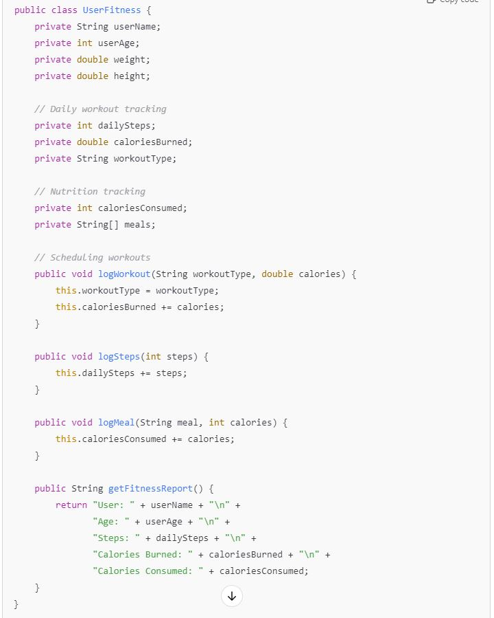

Tasks:
- Analyze the UserFitness class. Explain why this class has low cohesion. (5 pts.)

The UserFitness class demonstrates low cohesion because it takes on several unrelated responsibilities that should be divided. It handles workout tracking, nutrition tracking, personal details, and scheduling workouts.

- Describe, in general, how you would split the UserFitness class into more cohesive classes. Your answer should not be a complete design. (5 pts.)

To improve this cohesion, I would break the UserFitness class into several smaller focused classes. Each is responsible for a single aspect of fitness management.

Question 2. (5 pts.)
Given the following, answer the below questions.

A university manages its students using a program that has a class Student with subclasses FirstYear, SecondYear, and ThirdYear for year-specific state and behaviors. The program has a List that contains all Students.

Should Student be a class, an abstract class or an interface? Explain your answer

Student should be an abstract class because it allows the definition of shared attributes and behaviors that all student types, regardless of year. This promotes code reuse and ensures that specific behaviors or properties unique to each year can be implemented in the subclasses. The abstract class prevents this while enforcing that only concrete subclasses like FirstYear or SecondYear can be created.

- At the end of each year, the third-year students graduate and must be removed. This is done by passing the list to the following method:

void removeThirdYears(List<Students> students) {
for (Student student : students) {
try {
ThirdYear = (ThirdYear) student;
students.remove(thirdyear);
}
}
}

Why is the above method flawed? Hint: Another Arthur Riel heuristic (5 pts.)

The method is flawed because it modifies the list while iterating over it which can cause a concurrentmodificationexception. A method should not change the collection it is iterating over. Removing elements during iteration breaks this rule and can lead to unpredictable behavior.

Question 3. (5 pts.)
Given the following, answer the below questions.

public class BankAccount {
public String accountHolderName;
public String accountNumber;
public double balance;
public double interestRate;

public BankAccount(
String accountHolderName,
String accountNumber,
double initialDeposit,
double interestRate) {
this.accountHolderName = accountHolderName;
this.accountNumber = accountNumber;
this.balance = initialDeposit;
this.interestRate = interestRate;
}

// Exposed implementation for adding interest
public void addInterest() {
double interest = balance * (interestRate / 100);
balance += interest;
}

// Exposed implementation for deposits
public void deposit(double amount) {
balance += amount;
}

// Exposed implementation for withdrawals
public void withdraw(double amount) {
balance -= amount;
}
}

- Is BankAccount well-encapsulated? Why or why not? If so, describe what changes you would make to the class. Otherwise, state nothing. (5 pts.)

The BankAccount class is not well-encapsulated because it fields accountHolderName, accountNumber, balance, and interstate are public. This allows external access and modification. In order to properly encapsulate the class these fields should be made private. This ensures internal state of the class is protected from unintended changes.

Question 4. (10 pts.)
Given the following, answer the below questions.

Given:
A car manufacturer uses Java software to track current vehicles being built. The UML diagram below shows an excerpt of the current software structure. You should assume the presence of other appropriate fields and methods

Car
getTrimLevel()
Engine
accelerate()
getFuelLevel()
Base
Sports
Luxury
Electric
Petrol

Each car can be built to one of three trim levels: Base, Luxury or Sport. They can also be configured with an electric or petrol engine. At various points in the manufacturing process the customer can choose to change the trim level.

Task:
- Explain in detail why the current structure does not support this. (5 pts.)
The current structure uses rigid subclassing making it difficult to modify them dynamically. This prevents easy changes during manufacturing, as changing trim would require creating a new object instead of simply updating the trim level.

- Describe how to refactor the structure to allow trim-level change for a car to dynamically change. Hint: How would you modify Car to use composition to solve the problem? (5 pts.)

The car class should be refactored to use composition by creating a TrimLevel class that encapsulates the different trim options and their properties. The Car class can maintain a reference to a TrimLevel object this way.

Question 5. (5 pts.)
Suppose you are about to code a particular class and find that you have written another class with nearly the functionality that you now are developing. This means that the two classes in large parts contain the same code, but in smaller parts have different code. Explain in detail why this may be a problem and how to solve it. Give your answer in terms of Arthur Riel’s design heuristics.

Two classes with overlapping functionality leads to code duplication making maintenance difficult and increasing the risk of errors. Arthur Riel’s design heuristics suggest extracting the common functionality into a base or utility class. Allowing specific classes to inherit or compose from it.

Question 6. (5 pts.)
Suppose we need to store instances of the classes Car and BankAccount in a database. To obtain low coupling it may seem as if the functionality to save an instance should be in precisely those classes, since they have the information that shall be saved. Why is it unwise to place the database calls there?

This creates tight coupling between the domain model and the database layer, making it harder to change the data storage method later. This violates the stage responsible principle. These classes would handle both business logic and persistence.

Question 7. (5 pts.)
Given a set of requirements, what conditions must be met to make it appropriate to create a new class hierarchy using inheritance? Neither superclass nor subclass exist before, the question is about designing a new class hierarchy.

To create a new class hierarchy using inheritance, there should be a clear relationship among the classes, where subclasses also account for potential reuse and extensibility, ensuring that subclasses can add specific functionality without modifying the superclass.

Question 8. (2.5 pts.)
Describe the difference between inheritance and composition why would you choose one over the other.

Inheritance defines a relationship where a subclass inherits behavior and properties from a superclass while composition defines a has-a relationship by combining objects to achieve functionality.

Question 9. (2.5 pts.)
Explain the meaning of cohesion and describe whether low or high cohesion is better.

Cohesion refers to how closely related and focused the responsibilities of a class or module are. High is better because it indicated that a class has a well defined purpose making it clear to understand and use.

Sources
- https://www.geeksforgeeks.org/software-engineering-coupling-and-cohesion/
- https://www.geeksforgeeks.org/encapsulation-in-java/

